**UNIVERSITY INSTITUTE OF TECHNOLOGY**

**BARKATULLAH UNIVERSITY, BHOPAL**

**Department of Computer Science & Engineering**

**MINOR PROJECT**

**ON**

**“E-DISHA (Way of Crowed Funding)”**

**Submitted for the partial fulfillment of the requirement for the**

**Award of Degree of**

**Bachelor of Engineering (B.E.)**

**Year 2019**

**University Institute of Technology**

**Barkatullah University, Bhopal**

**By**

**RISHI GOLE**

**Under the Guidance**

**of**

**Mahendra Jhariya Dr. Divakar Singh**

Project Guide Head of Department

CSE, UIT-BU CSE, UIT-BU

**UNIVERSITY INSTITUTE OF TECHNOLOGY**

**BARKATULLAH UNIVERSITY, BHOPAL**

**Department of Computer Science & Engineering**

**CERTIFICATE**

**YEAR 2019**

This is to certify that **Rishi Gole** have successfully completed this project work titled “**E-DISHA(Way of Crowed Funding)**” for the partial fulfillment of the award of degree of Bachelor of Engineering in Computer Science & Engineering in the year 2019 Barkatullah University Institute of Technology, Bhopal.

**Mahendra Jhariya Dr. Divakar Singh Dr. N.K Gaur**

Project Guide Head of Department Director

CSE, UIT-BU CSE, UIT-BU UIT-BU (Bhopal)

**UNIVERSITY INSTITUTE OF TECHNOLOGY**

**BARKATULLAH UNIVERSITY, BHOPAL**

**Department of Computer Science & Engineering**

**DECLARATION**

**YEAR 2019**

We hereby declare that the work which is being presented in this report entitled, “**E-DISHA (Way of Crowed Funding)”**submitted in partial fulfillment of the requirement for the award of Degree of “Bachelor of Engineering” in Computer Science and Engineering from University of Technology, BU, Bhopal is an authentic record of our project work.

This is our original work and has not been submitted earlier for the award of any other degree, diploma or any other certificate.

**Rishi Gole**

**ACKNOWLEDGMENT**

We would like to express our deepest appreciation to all those who provided us the possibility to complete this report. Before we get into the thick of the things we would like to add a few heartfelt words for the teachers who are part of this project in a numerous way. Teacher who gave us support right from the project idea were convinced. First of all we would like to thank our project guide **Mahendra Jhariya** for allowing us to undergo this major project idea. We would also like to pay our sincere regards to our **Divakar Singh** **(H.O.D. ,CSE)** for providing effective platform and support in the development of this project and finally we would like to render our thanks to our **Honorable Director N.k. Gaur** for his guidance in this project titled “**E-DISHA(Way of Crowed Funding)**”.Last but not the least we would like to thank our parent and friends for their support and cooperation. Regardless of the source we wish to express our gratitude to those who may have contributed to this work; even though anonymously.

**SUBMITTED BY: Rishi Gole**

**(R1882300193)**

**ABSTRACT**

The **E-DISHA (Way of Crowed Funding)** is the web application. It web services on computer systems. The main objective is to develop a web application that provides a easy and smart way for collecting funds. Crowd funding has enabled large crowds to fund innovative projects. This type of funding might tap into the wisdom of crowds who were previously disconnected from the funding process. We distinguish between in-crowd and out-crowd funders (with and without ties to project creators) in order to test for heterogeneity in their information use. Based on the analysis of a large-scale survey amongst project funders, this paper shows that in-crowd investors rely more on information about the project creator than out-crowd investors. Out-crowd investors do not seem to attach more importance to information about the project itself than in-crowd investors, except in the case of donation-based crowd funding. For financial-return crowd funding, financial information becomes less important once a strong relationship with the project creator is established. Our study allows project creators to target information to specific audiences based on their relationship strength across different types of crowd funding projects.

**TABLE OF CONTENTS**

**Topic Name Page No.**

List of Abbreviation 1

List of Table 2

**CHAPTER 1: INTRODUCTION 2**

1.1 Introduction 2

**CHAPTER 2: REQUIREMENTS**  3

2.2 Software and Hardware Requirements 3

2.2.1 Software Requirements 3

2.2.2 Hardware Requirements 3

# **CHAPTER 3: SOFTWARE DESCRIPTION 4-5**

3.1 Technologies and development tools

**CHAPTER 4: PROJECT DESCRIPTION 6-7**

4.1 PROBLEM DEFINITION 6-7

4.2 PROJECT OVERVIEW 6-7

4.3 MODULE DESCRIPTION 6-7

4.4 DIAGRAMS 6-7

**CHAPTER 4: CODING AND SNAPSHOT 8-11**

**CHAPTER 5: TESTING 12**

6.1 Unit Testing 12

6.2 Integration Testing 12

6.3 Acceptance Testing 12

**CHAPTER 6: CONCLUSION AND FUTURE ENHANCEMENT 13**

6.1 Conclusion 13

6.2 Scope for future development

**LIST OF ABBREVIATIONS:**

|  |  |  |
| --- | --- | --- |
| **S.NO** | **SYMBOL** | **DESCRIPTION** |
| **1.** | **HTML** | **Hypertext markup language.** |
| **2.** | **SQL** | **Structured query language.** |
| **3.** | **DBMS** | **Database management system.** |
| **4.** | **DNS** | **Domain name system.** |
| **5.** | **PHP** | **Hyper text preprocessor.** |
| **6.** | **CSS** | **Cascading styling sheets.** |
| **7.** | **Gb** | **Gigabyte** |
| **8.** | **IDE** | **Interactive Development Environment** |
| **9.** | **MYSQL** | **My Structured Query Language** |
| **10.** | **JQUERY** | **Java Query .** |

**CHAPTER 1**

1. **INTRODUCTION**

The E-DISHA(Way of Crowed Funding)is the project. It’s a website development project in which all the work is done digitally. This project involves the collecting the fund by small  is the use of small amounts of capital from a large number of individuals to finance a new business venture. Crowd funding makes use of the easy accessibility of vast networks of people through social media& via internet . and crowd funding websites to bring investors and entrepreneurs together, and has the potential to increase entrepreneurship by expanding the pool of investors from whom funds can be raised beyond the traditional circle of owners, relatives and venture capitalists. In recent years, crowd funding has emerged as a revolutionary financing model that allows small entrepreneurs to raise funding in the early stages of their projects, particularly those that may otherwise struggle to obtain capital. Today, there are approximately 1250 active crowd funding platforms across the world, which together channeled $16.2 billion in 2014, representing a 167 % increase from $6.1 billion in 2013. Having their project successfully funded is crucial to project creators as it provides not only initial funds for project development but also access to valuable future resources, and eventually turn their projects into successful entrepreneurial organizations.

**Table 1** Previously identified antecedents by category

|  |  |  |  |  |  |  |  |
| --- | --- | --- | --- | --- | --- | --- | --- |
| Category | Project | Success | Goal | Success rate | Funding ratio | Backers | Duration |
| Art | 12,255 | 6130 | 9160 | 50 % | 0.84 | 45.82 | 33.10 |
| Comics | 4274 | 2307 | 8466 | 54 % | 1.24 | 147.32 | 35.79 |
| Crafts | 1873 | 633 | 5794 | 34 % | 0.96 | 33.85 | 30.93 |
| Dance | 2064 | 1452 | 7302 | 70 % | 0.89 | 48.19 | 32.71 |
| Design | 8500 | 3585 | 23,385 | 42 % | 1.76 | 280.39 | 34.21 |
| Fashion | 6781 | 2135 | 11,986 | 31 % | 0.73 | 76.97 | 32.68 |
| Film & video | 34,194 | 15,334 | 20,417 | 45 % | 0.62 | 71.28 | 35.77 |
| Food | 7781 | 2832 | 19,493 | 36 % | 0.67 | 77.85 | 33.76 |
| Games | 10,023 | 4235 | 27,520 | 42 % | 1.85 | 417.15 | 33.39 |
| Journalism | 1101 | 395 | 11,833 | 36 % | 0.53 | 58.91 | 35.14 |
| Music | 28,662 | 16,989 | 7289 | 59 % | 0.81 | 61.90 | 35.71 |
| Photography | 4846 | 1767 | 8179 | 36 % | 0.59 | 46.55 | 34.72 |
| Publishing | 17,117 | 5942 | 9037 | 35 % | 0.61 | 55.14 | 34.28 |
| Technology | 6235 | 1997 | 39,073 | 32 % | 1.28 | 262.84 | 34.83 |
| Theater | 6046 | 4051 | 9178 | 67 % | 0.85 | 53.19 | 33.83 |
| Overall | 151752 | 69784 | 14,541 | 46 % | 0.95 | 115.82 | 34.06 |

**CHAPTER : 2**

**SOFTWARE AND HARDWARE REQUIREMENTS.**

* **HARDWARE REQUIREMENTS:**

1. HDD : 1 Gb
2. RAM : 2Gb
3. **PROCESSOR**: Intel Pentium 4 or later.

* **SOFTWARE REQUIREMENTS.**

1. **EDITOR :** SUBLIME EDITOR 3, NOTEPAD, NOTEPAD++,CODELOBSTER IDE**.**
2. **LOCAL SERVER:** WAMP/XAMPP.
3. **DATABASE SERVER:** MYSQL.
4. **DESIGN TOOL :** PHOTOSHOP
5. **OPERATING SYSTEM:** ANY OPERATING SYSTEM.

* **TECHNOLOGY USED:**

**FRONTEND :** HTML , CSS, JOUERY, JSCRIPT, ANGULAR JS, BOOTSTRAP.

* **SERVERSIDE SCRIPTING LANGUAGE:**

1. PHP

* **BACKEND :**

1. MYSQL.

**CHAPTER 3**

**SOFTWARE DESCRIPTION**

**3.1 TECHNOLOGIES AND DEVELOPMENT TOOLS:**

**3.1.1 PHP** :PHP (recursive acronym for PHP: Hypertext Preprocessor) is a widely-used Server side and open source general-purpose scripting language that is especially suited for web development and can be easily embedded into HTML. Originally, it is created by Rasmus Lerdorf in 1994.

**Advantage of php:**

* PHP can generate dynamic page content.
* PHP can create, open, read, write, delete, and close files on the server.
* PHP can collect form data.
* PHP can send and receive cookies.
* PHP can add, delete, modify data in your database.
* PHP can be used to control user-access.
* PHP can encrypt data.
* PHP runs on various platforms (Windows, Linux, Unix, Mac OS X, etc.).
* PHP is compatible with almost all servers used today (Apache, IIS, etc.).
* PHP supports a wide range of databases.
* PHP is free. Download it from the official PHP resource: www.php.net.
* PHP is easy to learn and runs efficiently on the server side.

3.1.2 **HTML:**

HTML is the standard markup language for creating Web pages.

* HTML stands for Hyper Text Markup Language.
* HTML describes the structure of Web pages using markup.
* HTML elements are the building blocks of HTML pages.
* HTML elements are represented by tags.
* HTML tags label pieces of content such as "heading", "paragraph", "table", and so on.
* Browsers do not display the HTML tags, but use them to render the content of the page.

3.1.3 **CSS :**

* CSS stands for Cascading Style Sheets.
* CSS describes how HTML elements are to be displayed on screen, paper, or in other media.
* CSS saves a lot of work. It can control the layout of multiple web pages all at once.
* External stylesheets are stored in CSS files.

3.1.4 **java script:**

* **JavaScript** to program the behavior of web pages.
* JavaScript is the programming language of HTML and the Web.
* Programming makes computers do what you want them to do.
* JavaScript is easy to learn.

**DATABASE**

**MySQL :**

* MySQL is a database system used on the web.
* MySQL is a database system that runs on a server.
* MySQL is ideal for both small and large applications.
* MySQL is very fast, reliable, and easy to use.
* MySQL uses standard SQL.
* MySQL compiles on a number of platforms.
* MySQL is free to download and use.
* MySQL is developed, distributed, and supported by Oracle Corporation.

**CHAPTER 4**

**PROJECT DESCRIPTION**

**4.1 PROBLEM DEFINITION:**

The E-DISHA(Way of Crowed Funding)is the project. It’s a website development project in which all the work is done digitally. This project involves the collecting the fund by small amounts of capital from a large number of individuals to finance a new business venture. Crowd funding makes use of the easy accessibility of vast networks of people through social media & via internet and crowd funding websites to bring investors and entrepreneurs together, and has the potential to increase entrepreneurship by expanding the pool of investors from whom funds can be raised beyond the traditional circle of owners, relatives and venture capitalists.

**4.2 PROJECT OVERVIEW**

Crowed funding Website has the following module.

* Admin module is has rights to verify the fundraiser details.
* Fundraisers request the admin to approve the funding details.
* Donor Can Donate the Fund to current causes.
  1. **MODULE DESCRIPTION**

The system should be designed in such a way that only verified Fundraiser should be allowed to get the fund for their verified causes. The funding details should be modified by only Fundraiser and no one else. And the fundraiser causes details verified by admin and then the cause will show on the website. After that the donor can easily donate the fund for the current causes.

The user interface should be consistent so that the user can handle the application with ease and speed. The application should be visually, conceptually clear.

**Diagrams:**

1. **Activity Diagram of Fundraiser**

Login/Signup

Website

Fundraiser

Request

Approved

E-DISha Admin

**Disapprove/Exit**

Request for approval of fundraiser details

Database

1. **Activity Diagram of Donor**

Website

Donor/user

Causes Description

Current Causes

Donate Now

Donation Successful

Database

Login/Signup

**CHAPTER: 5**

**CODING AND SNAPSHOT**

<?php

define("BYPASS_PAGE_ID",TRUE);

define("BYPASS_SESSION",TRUE);

include("vendor.php");

$select = $db->select("needypersondetails","*",array("status"=>"Approve"));

//varPrint($select);

include("includes/header.php");

?>

<!-- Start slider area -->

<section class="slider-animate-area pb-60">

<div class="container">

<div class="row">

<div class="col-sm-12 text-center">

<div class="cd-intro">

<h1 class="cd-headline clip is-full-width title1 wow zoomIn animated" data-wow-duration="1s" data-wow-delay="300ms" style="visibility: visible; animation-duration: 1s; animation-delay: 300ms; animation-name: zoomIn;">

<span>WE CAN HELP </span>

<span class="cd-words-wrapper">

<b class="is-visible">SOMEONE</b>

<b>SOMEONE</b>

<b>SOMEONE</b>

</span>

</h1>

<p class="wow zoomIn animated" data-wow-duration="1s" data-wow-delay="600ms" style="visibility: visible; animation-duration: 1s; animation-delay: 600ms; animation-name: zoomIn;">E-DISHA makes sure that your donations reach the right people through an extensive verification process.</p>

<div class="slider-button-area wow zoomIn animated" data-wow-duration="1s" data-wow-delay="900ms" style="visibility: visible; animation-duration: 1s; animation-delay: 900ms; animation-name: zoomIn;">

<a href="donation_categories.php" class="btn-lg">DONATE NOW</a>

<a href="login.php" class="btn-lg">Start A Fundriser</a>

</div>

</div>

</div>

</div>

</div>

</section>

<!-- End slider area -->

<!-- End slider area -->

<!-- Start our couses area -->

<section class="our-couses-area pt-90 pb-90">

<div class="col-sm-12">

<div class="section-title text-center">

<h2>OUR <span>CAUSES</span></h2> <img src="img\title-bottom.png" alt="">

<p>Our charity help those people who have no hope</p>

</div>

<div class="col-md-12">

<div class="row">

<div class="MultiCarousel" data-items="0,1,2,3" data-slide="1" id="MultiCarousel1" data-interval="1000">

<div class="MultiCarousel-inner" style="transform: translateX(0px); width: 1710px;">

<meta name="viewport" content="width=device-width, initial-scale=1.0">

<?php

$Pcontent = $db->select("needypersondetails","*",array("status"=>"Approve"));

foreach($Pcontent as $content)

<div class="item" style="width: 190px;">

<div style="background-color: white;">

<!-- Start single blog -->

<div class="col-sm-12">

<div class="single-blog">

<div class="blo-image-and-date">

<img src="admin2/includes/img/<?php echo $content->photo;?>" alt="" style="height: 250px; padding:10px; width: auto;">

</div>

<div class="blog-info">

<div class="admin" style="border:1px solid #ff0000;text-align: center;background: red;color: cornsilk;">

<?php echo $content->NeedFor; ?>

</div>

<div class="comment">

<a href="#"><i class="fa fa-heart" aria-hidden="true"></i> 15</a>

<a href="#"><i class="fa fa-comment" aria-hidden="true"></i> 25</a>

</div>

</div>

<div class="blog-text">

<h3><a href="#" style="color: #0aaaa0;"><?php echo $content->Tital;?></a></h3>

</div>

<div class="row">

<div class="couses-button-and-price">

<div class="col-md-6">

<div class="couses-button">

<a href="patientdetailpage.php?id=<?php echo $content->sno; ?>" class="btn-md bo-ra-5"style="background-color:#0aaaa0; color: black; margin: 15px;border: 1px solid white;">Donate</a>

</div>

</div>

<div class="col-md-6" style="margin-top: -15px;">

<div class="couses-price" style="margin-right: 30px; margin-top:5px;">

<h5 style="font-size: 20px;">₹ <?php echo $content->InitialAmount;?></h5>

</div>

</div>

</div>

</div></div>

</div>

<!-- End single blog -->

</div>

</div>

<?php

</div><button class="leftLst over" style="background-color:transparent;color:white; ;font-size:50px; border:none; text-shadow: 4px 4px 8px black;"><span class="glyphicon glyphicon-chevron-left"></span></button>

<button class="rightLst" style="background-color:transparent;color:white; ;font-size:50px; border:none; text-shadow: 4px 4px 8px black;"><span class="glyphicon glyphicon-chevron-right"></span></button>

</div>

</div>

</div>

<style>

.mr-row1-left, .mr-row1-right {

float: left;

-webkit-box-sizing: border-box;

-moz-box-sizing: border-box;

-o-box-sizing: border-box;

-ms-box-sizing: border-box;

box-sizing: border-box;

width: 61%;

border-right: solid 1px #e5e5e5;

position: relative;

}

.intro-pic {

width: 45%;

position: relative;

}

.mr-row1-left .intro-txt {

background: #FFF;

width: 60%;

top: 0;

left: 42%;

position: absolute;

padding: 36px;

-moz-box-shadow: 5px 6px 5px rgba(33, 30, 31, .4);

-webkit-box-shadow: 5px 6px 5px rgba(33, 30, 31, .4);

box-shadow: 5px 6px 5px rgba(33, 30, 31, .4);

z-index: 50;

}

.intro-pic img {

width: 100%;

}

element.style {

}

.mr-row1, .mr-row2 {

position: relative;

padding: 0 0 2em 0;

margin: 0 auto 2em auto;

border-bottom: solid 1px #e5e5e5;

}

.mCustomScrollbar {

-ms-touch-action: pinch-zoom;

touch-action: pinch-zoom;

}

.whoare-contents {

height: 330px;

overflow: auto;

position: relative;

}

.mCustomScrollBox {

position: relative;

overflow: hidden;

height: 100%;

max-width: 100%;

outline: none;

direction: ltr;

}

.mCustomScrollBox {

position: relative;

overflow: hidden;

height: 100%;

max-width: 100%;

outline: none;

direction: ltr;

}

.mCSB_inside > .mCSB_container {

margin-right: 30px;

}

.mCSB_container {

overflow: hidden;

width: auto;

height: auto;

}

element.style {

display: block;

}

.mCSB_scrollTools {

opacity: 0.75;

filter: "alpha(opacity=75)";

-ms-filter: "alpha(opacity=75)";

}

.mCSB_scrollTools, .mCSB_scrollTools .mCSB_dragger .mCSB_dragger_bar, .mCSB_scrollTools .mCSB_buttonUp, .mCSB_scrollTools .mCSB_buttonDown, .mCSB_scrollTools .mCSB_buttonLeft, .mCSB_scrollTools .mCSB_buttonRight {

-webkit-transition: opacity .2s ease-in-out, background-color .2s ease-in-out;

-moz-transition: opacity .2s ease-in-out, background-color .2s ease-in-out;

-o-transition: opacity .2s ease-in-out, background-color .2s ease-in-out;

transition: opacity .2s ease-in-out, background-color .2s ease-in-out;

}

.mCSB_scrollTools {

position: absolute;

width: 16px;

height: auto;

left: auto;

top: 0;

right: 0;

bottom: 0;

}

.intro-txt p {

font-family: "Baskerville", Georgia, Times, Serif;

font-size: 1.2em;

line-height: 1.5em;

color: #111;

font-style: italic;

text-align: justify;

}

.intro-txt h2 {

text-align: center;

font-family: "AvantGarde", Arial, Sans-serif;

font-size: 1.5em;

line-height: 1.2;

text-transform: uppercase;

color: #000;

letter-spacing: 0.01em;

}

.button {

background-color: #4CAF50; /* Green */

border: none;

color: white;

padding: 16px 32px;

text-align: center;

text-decoration: none;

display: inline-block;

font-size: 16px;

margin: 4px 2px;

-webkit-transition-duration: 0.4s; /* Safari */

transition-duration: 0.4s;

cursor: pointer;

}

.button3 {

background-color:transparent;

color: black;

border: 10px solid #f44336;

width:250px;

}

.button3:hover {

background-color: #f44336;

color: white;

}

.MultiCarousel { float: left; overflow: hidden; padding: 15px; width: 100%; position:relative; }

.MultiCarousel .MultiCarousel-inner { transition: 1s ease all; float: left; }

.MultiCarousel .MultiCarousel-inner .item { float: left;}

.MultiCarousel .MultiCarousel-inner .item > div { text-align: center; padding:10px; margin:10px; background:#f1f1f1; color:#666;}

.MultiCarousel .leftLst, .MultiCarousel .rightLst { position:absolute; border-radius:50%;top:calc(50% - 20px); }

.MultiCarousel .leftLst { left:0; }

.MultiCarousel .rightLst { right:0; }

.MultiCarousel .leftLst.over, .MultiCarousel .rightLst.over { pointer-events: none; background:#ccc; }

</style>

<script>

$(document).ready(function () {

var itemsMainDiv = ('.MultiCarousel');

var itemsDiv = ('.MultiCarousel-inner');

var itemWidth = "";

$('.leftLst, .rightLst').click(function () {

var condition = $(this).hasClass("leftLst");

if (condition)

click(0, this);

else

click(1, this)

});

ResCarouselSize();

$(window).resize(function () {

ResCarouselSize();

});

//this function define the size of the items

function ResCarouselSize() {

var incno = 0;

var dataItems = ("data-items");

var itemClass = ('.item');

var id = 0;

var btnParentSb = '';

var itemsSplit = '';

var sampwidth = $(itemsMainDiv).width();

var bodyWidth = $('body').width();

$(itemsDiv).each(function () {

id = id + 1;

var itemNumbers = $(this).find(itemClass).length;

btnParentSb = $(this).parent().attr(dataItems);

itemsSplit = btnParentSb.split(',');

$(this).parent().attr("id", "MultiCarousel" + id);

if (bodyWidth >= 1200) {

incno = itemsSplit[3];

itemWidth = sampwidth / incno;

}

else if (bodyWidth >= 992) {

incno = itemsSplit[2];

itemWidth = sampwidth / incno;

}

else if (bodyWidth >= 768) {

incno = itemsSplit[1];

itemWidth = sampwidth / incno;

}

else {

incno = itemsSplit[0];

itemWidth = sampwidth / incno;

}

$(this).css({ 'transform': 'translateX(0px)', 'width': itemWidth * itemNumbers });

$(this).find(itemClass).each(function () {

$(this).outerWidth(itemWidth);

});

$(".leftLst").addClass("over");

$(".rightLst").removeClass("over");

});

}

//this function used to move the items

function ResCarousel(e, el, s) {

var leftBtn = ('.leftLst');

var rightBtn = ('.rightLst');

var translateXval = '';

var divStyle = $(el + ' ' + itemsDiv).css('transform');

var values = divStyle.match(/-?[\d\.]+/g);

var xds = Math.abs(values[4]);

if (e == 0) {

translateXval = parseInt(xds) - parseInt(itemWidth * s);

$(el + ' ' + rightBtn).removeClass("over");

if (translateXval <= itemWidth / 2) {

translateXval = 0;

$(el + ' ' + leftBtn).addClass("over");

}

}

else if (e == 1) {

var itemsCondition = $(el).find(itemsDiv).width() - $(el).width();

translateXval = parseInt(xds) + parseInt(itemWidth * s);

$(el + ' ' + leftBtn).removeClass("over");

if (translateXval >= itemsCondition - itemWidth / 2) {

translateXval = itemsCondition;

$(el + ' ' + rightBtn).addClass("over");

}

}

$(el + ' ' + itemsDiv).css('transform', 'translateX(' + -translateXval + 'px)');

}

//It is used to get some elements from btn

function click(ell, ee) {

var Parent = "#" + $(ee).parent().attr("id");

var slide = $(Parent).attr("data-slide");

ResCarousel(ell, Parent, slide);

}

});

</script>

</section>

<!-- End our couses area -->

<section class="what-we-do-area pb-70">

<div class="container">

<div class="row">

<!-- Start section title -->

<div class="col-sm-12">

<div class="section-title text-center">

<h2>Browse <span>Fundraisers</span></h2>

<img src="img\title-bottom.png" alt="">

<p>We create events aiming to pear to the voice for children and gather for support. <br>Please update with our events and confirm you presence.</p>

</div>

</div>

<!-- End section title -->

<div class="what-we-do">

<!-- Start single we do -->

<div class="col-sm-3">

<a href="campaginlist.php?id=Education">

<div class="single-we-do">

<div class="we-do-image">

<img src="img/about/we-do-one.jpg" alt="">

</div>

<div class="we-do-text" style="background: center;">

<h5>DONATE FOR EDUCATION</h5>

</div>

</div>

</a>

</div>

<!-- End single we do -->

<!-- Start single we do -->

<div class="col-sm-3">

<a href="campaginlist.php?id=Food">

<div class="single-we-do">

<div class="we-do-image">

<img src="img\about\we-do-two.jpeg" alt="">

</div>

<div class="we-do-text" style="background: center;">

<h5>DONATE FOR FOOD</h5>

</div>

</div>

</a>

</div>

<!-- End single we do -->

<!-- Start single we do -->

<div class="col-sm-3">

<a href="campaginlist.php?id=Water">

<div class="single-we-do">

<div class="we-do-image">

<img src="img/about/water.jpeg" alt="">

</div>

<div class="we-do-text" style="background: center;">

<h5>DONATE FOR WATER</h5>

</div>

</div>

</a>

</div>

<!-- End single we do -->

<!-- Start single we do -->

<div class="col-sm-3">

<a href="campaginlist.php?id=Sports">

<div class="single-we-do">

<div class="we-do-image">

<img src="img/about/we-do-three.jpg" alt="">

</div>

<div class="we-do-text" style="background: center;">

<h5>DONATE FOR SPORTS</h5>

</div>

</div>

</a>

</div>

<!-- End single we do -->

</div>

<div class="what-we-do">

<!-- Start single we do -->

<div class="col-sm-3" style="padding-top: 15px;">

<a href="campaginlist.php?id=Children">

<div class="single-we-do">

<div class="we-do-image">

<img src="img/about/we-do-one2.jpeg" alt="">

</div>

<div class="we-do-text" style="background: center;">

<h5 style="color:#136888">DONATE FOR CHILDREN</h5>

</div>

</div>

</a>

</div>

<!-- End single we do -->

<!-- Start single we do -->

<div class="col-sm-3" style="padding-top: 15px;">

<a href="campaginlist.php?id=Community Devlopment">

<div class="single-we-do">

<div class="we-do-image">

<img src="img\about\we-do-two.jpeg" alt="">

</div>

<div class="we-do-text" style="background: center;"> <h5 style="color:#136888">DONATE FOR COMMUNITY</h5>

</div>

</div>

</a>

</div>

<!-- End single we do -->

<!-- Start single we do -->

<div class="col-sm-3" style="padding-top: 15px;">

<a href="campaginlist.php?id=Creativity">

<div class="single-we-do">

<div class="we-do-image">

<img src="img/about/creative.jpeg" alt="">

</div>

<div class="we-do-text" style="background: center;">

<h5 style="color:#136888">DONATE FOR CREATIVITY</h5>

</div>

</div>

</a>

</div>

<!-- End single we do -->

<!-- Start single we do -->

<div class="col-sm-3" style="padding-top: 15px;">

<a href="campaginlist.php?id=Health">

<div class="single-we-do">

<div class="we-do-image">

<img src="img/about/we-do-one2.jpg" alt="">

</div>

<div class="we-do-text" style="background: center;">

<h5 style="color:#136888">DONATE FOR HEALTH</h5>

</div>

</div>

</a>

</div>

<!-- End single we do -->

</div>

</div>

</div>

</section>

<!-- Start help us area -->

<section class="help-us-area pt-80 pb-80">

<div class="container">

<div class="row">

<div class="col-sm-12">

<div class="section-title-style-two text-center">

<h2>HOW CAN YOU HELP US?</h2>

<p>Step 1: Create your fundraiser instantly.<br>

Step 2: Share your fundraiser online.<br>

Step 3:Receive donations from around the world.<br>

Step 4: Transfer funds to the account directly. </p>

</div>

</div>

<div class="help-us-content-area">

<!-- Start single help -->

<div class="col-sm-4">

<div class="single-help">

<div class="help-icon">

<i class="fa fa-university" aria-hidden="true"></i>

</div>

<div class="help-text">

<h3>fundraiser</h3>

<p>Fill in a few details about yourself, and who you are fundraising for. It takes less time..</p> </div>

</div>

</div>

<!-- End single help -->

<!-- Start single help -->

<div class="col-sm-4">

<div class="single-help">

<div class="help-icon">

<i class="fa fa-money" aria-hidden="true"></i>

</div>

<div class="help-text">

<h3>Start crowdfunding</h3>

<p>Receive donations from friends, family and even strangers across the world..</p>

</div>

</div>

</div>

<!-- End single help -->

<!-- Start single help -->

<div class="col-sm-4">

<div class="single-help">

<div class="help-icon">

<i class="fa fa-users" aria-hidden="true"></i>

</div>

<div class="help-text">

<h3 >charges</h3>

<p>Transfer funds to the account directly without any fees.</p>

</div>

</div>

</div>

<!-- End single help -->

</div>

</div>

</div>

</section>

<!-- End help us area -->

<!-- Start our gallery -->

<section class="our-gallery pt-90 pb-60">

<div class="container">

<div class="row">

<!-- Start section title -->

<div class="col-sm-12">

<div class="section-title text-center">

<h2>OUR <span>Gallery</span></h2>

<img src="img\title-bottom.png" alt=""> <p>We create events aiming to pear to the voice for children and gather for support. <br>Please update with our events and confirm you presence.</p>

</div>

</div>

<!-- End section title -->

<div class="gallery-area">

<div class="col-sm-12">

<div class="gallery-menu text-center">

<nav>

<ul>

<li class="filter" data-filter="all">All</li>

<li class="filter" data-filter="Charity">Charity</li>

<li class="filter" data-filter="Nature">Nature</li>

<li class="filter" data-filter="Wildlife">Wildlife</li>

<li class="filter" data-filter="Children">Children</li>

</ul>

</nav>

</div>

</div>

<div id="gallery-filter">

<!-- Start single gallery -->

<div class="col-sm-3 mb-30 single-gallery mix all Charity Wildlife ">

<div class="gallery-image-and-text">

<img class="img-responsive" src="img/gallery/children.jpeg" alt="">

<a class="image-link text-center" href="img\gallery\children.jpeg">

<i class="fa fa-plus-square-o" aria-hidden="true"></i>

/a>

</div> </div>

<!-- End single gallery -->

<!-- Start single gallery -->

<div class="col-sm-3 mb-30 single-gallery mix all Nature Video">

<div class="gallery-image-and-text">

<img class="img-responsive" src="img/gallery/children1.jpeg" alt="">

<a class="image-link text-center" href="img\gallery\children1.jpeg">

<i class="fa fa-plus-square-o" aria-hidden="true"></i>

</a>

</div> </div>

<!-- End single gallery -->

<!-- Start single gallery -->

<div class="col-sm-3 mb-30 single-gallery mix all Charity Wildlife Children">

<div class="gallery-image-and-text">

<img class="img-responsive" src="img\gallery\gallery-three.jpeg" alt="">

<a class="image-link text-center" href="img\gallery\gallery-three.jpeg">

<i class="fa fa-plus-square-o" aria-hidden="true"></i>

</a>

</div>

</div>

<!-- End single gallery -->

<!-- Start single gallery -->

<div class="col-sm-3 mb-30 single-gallery mix all Nature Video">

<div class="gallery-image-and-text">

<img class="img-responsive" src="img/gallery/wildlife.jpeg" alt="">

<a class="image-link text-center" href="img\gallery\wildlife.jpeg">

<i class="fa fa-plus-square-o" aria-hidden="true"></i>

</a>

</div>

</div>

<!-- End single gallery -->

<!-- Start single gallery -->

<div class="col-sm-3 mb-30 single-gallery mix all Charity Wildlife Video Children">

<div class="gallery-image-and-text">

<img class="img-responsive" src="img\gallery\nature.jpeg" alt="">

<a class="image-link text-center" href="img\gallery\nature.jpeg">

<i class="fa fa-plus-square-o" aria-hidden="true"></i>

</a>

</div> </div>

<!-- End single gallery -->

<!-- Start single gallery -->

<div class="col-sm-3 mb-30 single-gallery mix all Nature Children">

<div class="gallery-image-and-text">

<img class="img-responsive" src="img/gallery/charity1.jpeg" alt="">

<a class="image-link text-center" href="img\gallery\charity1.jpeg">

<i class="fa fa-plus-square-o" aria-hidden="true"></i>

</a>

</div>

</div>

<!-- End single gallery -->

<!-- Start single gallery -->

<div class="col-sm-3 mb-30 single-gallery mix all Charity Wildlife Video">

<div class="gallery-image-and-text">

<img class="img-responsive" src="img\gallery\gallery-seven.jpeg" alt="">

<a class="image-link text-center" href="img\gallery\gallery-seven.jpeg">

<i class="fa fa-plus-square-o" aria-hidden="true"></i>

</a>

</div>

</div>

<!-- End single gallery -->

<!-- Start single gallery -->

<div class="col-sm-3 mb-30 single-gallery mix all Nature Children">

<div class="gallery-image-and-text">

<img class="img-responsive" src="img\gallery\gallery-eight.jpeg" alt="">

<a class="image-link text-center" href="img\gallery\gallery-eight.jpeg">

<i class="fa fa-plus-square-o" aria-hidden="true"></i>

</a>

</div>

</div>

<!-- End single gallery -->

</div>

</div>

</div>

</div>

</section>

<!-- End our gallery -->

<!-- Start countdown area -->

<section class="countdown-area pt-60 pb-60">

<div class="cont>

</div>

<div class="col-md-4 text-centre" style=" margin-top: 23px; text-align: center;">

<a class="resp-sharing-button__link" href="https://plus.google.com/share?url=http%3A%2F%2Fsharingbuttons.io" target="_blank" rel="noopener" aria-label="Share on Google+">

<div class="resp-sharing-button resp-sharing-button--google resp-sharing-button--large"><div aria-hidden="true" class="resp-sharing-button__icon resp-sharing-button__icon--solid"style=" width: 300px;">

</svg>

</div>Share on Google+</div>

</a>

</div>

</div>

</div>

</div> </section>

<!-- End brand logo area -->

<!-- Start footer -->

<?php

include("footer.php");

?

<!-- End footer -->

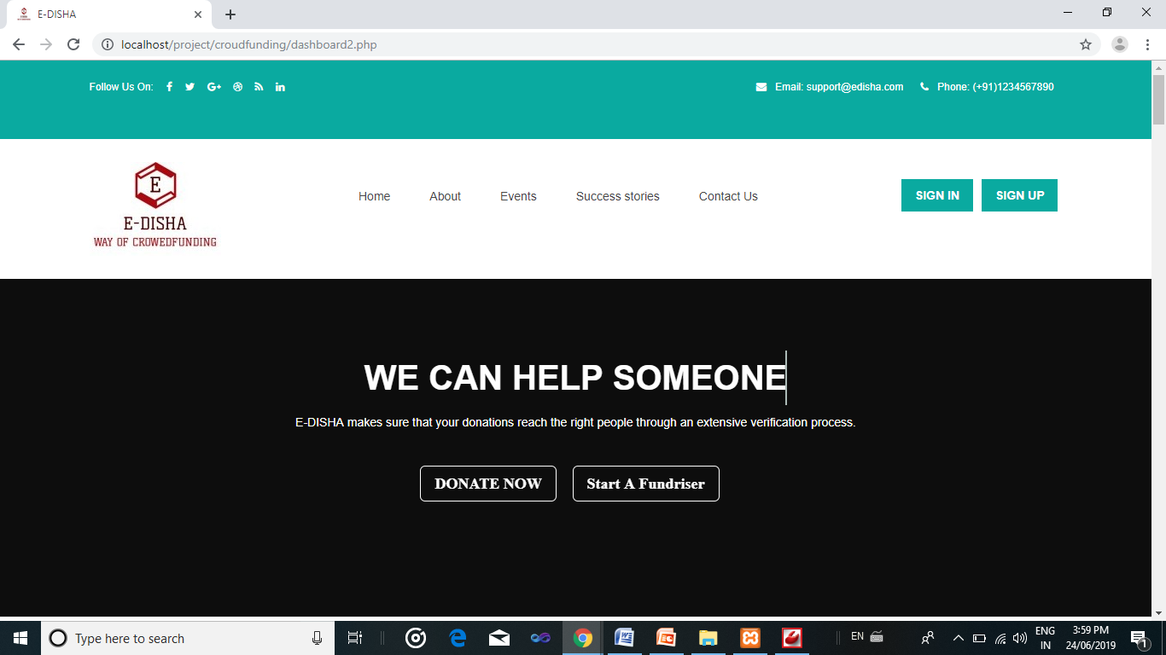Fig 5.1 –HomePage

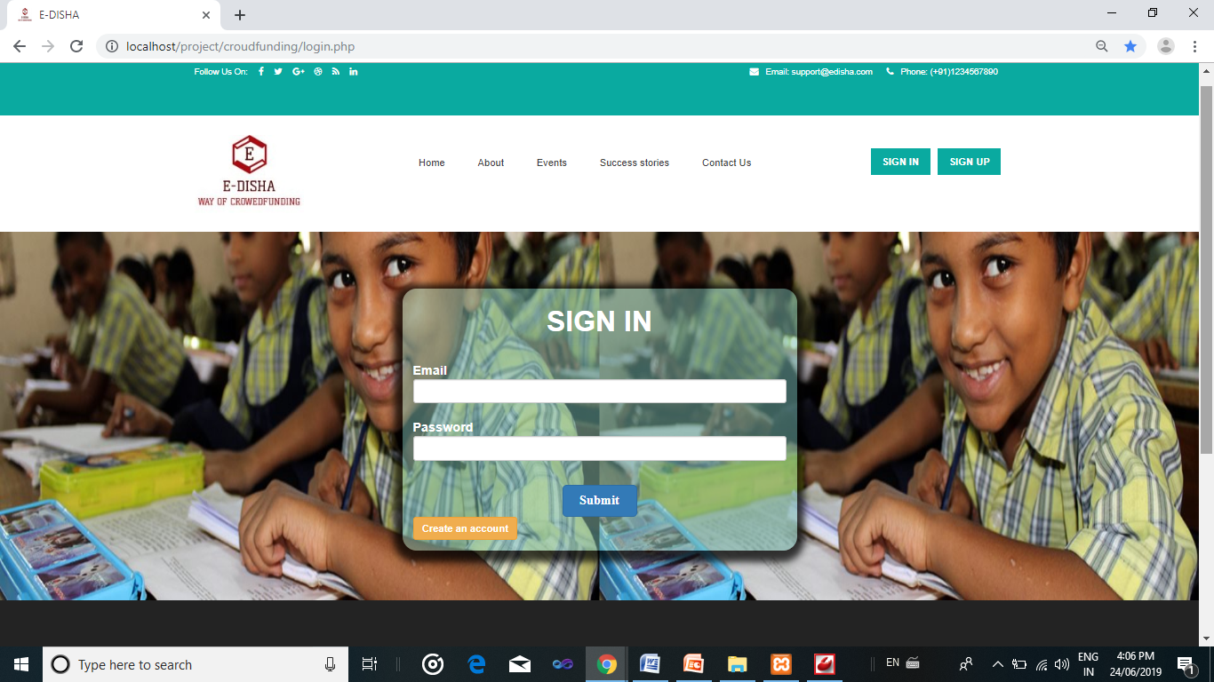

Fig 5.2 –LoginPage

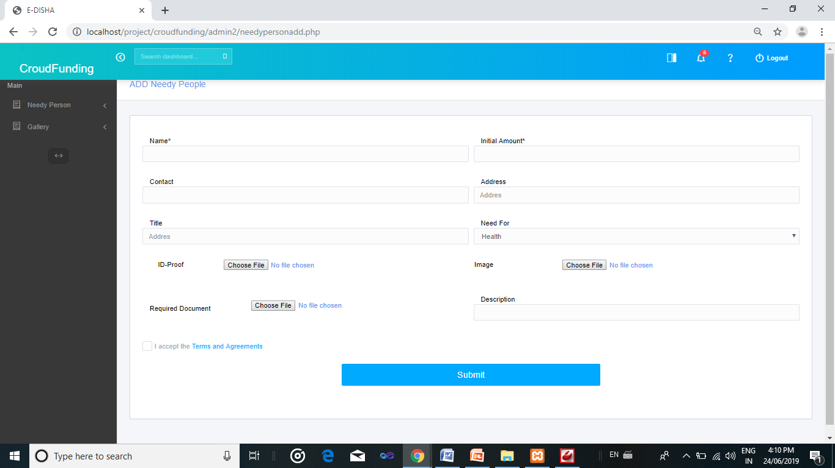

Fig 5.3 – Fundraiser details

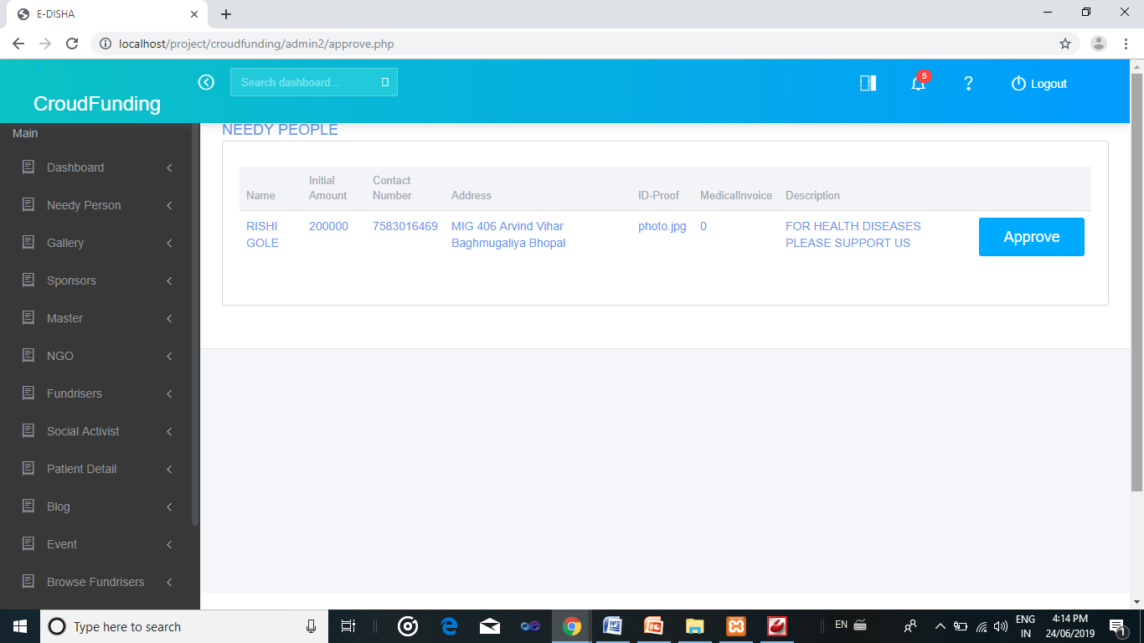

Fig 5.4 – Approve page

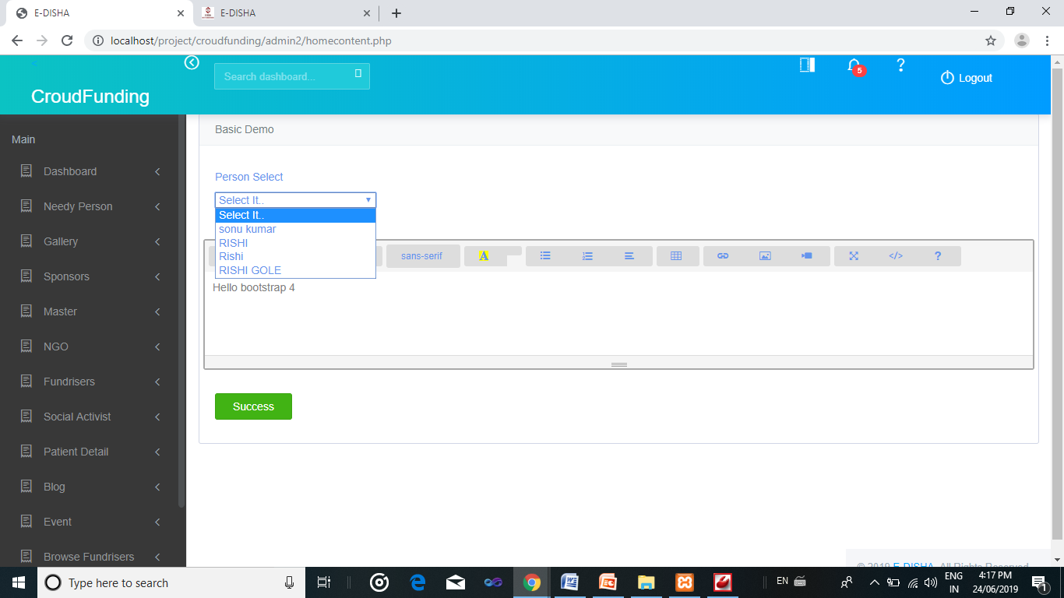

Fig 5.5 –Fundraiser descriptions

**CHAPTER 6**

**TESTING**

**UNIT TESTING:**

**UNIT TESTING** is a level of software testing where individual units/ components of a software are tested. The purpose is to validate that each unit of the software performs as designed. A unit is the smallest testable part of any software. It usually has one or a few inputs and usually a single output. In procedural programming, a unit may be an individual program, function, procedure, etc. In object-oriented programming, the smallest unit is a method, which may belong to a base/ super class, abstract class or derived/ child class. (Some treat a module of an application as a unit. This is to be discouraged as there will probably be many individual units within that module.) Unit testing frameworks, drivers, stubs, and mock/ fake objects are used to assist in unit testing.

**ACCEPTENCE TESTING:**

**Acceptance testing** is a level of software testing where a system is tested for acceptability. The purpose of this test is to evaluate the system’s compliance with the business requirements and assess whether it is acceptable for delivery.

**INTEGRATION TESTING:**

**Integration testing** is a level of software testing where individual units are combined and tested as a group. The purpose of this level of testing is to expose faults in the interaction between integrated units. Test drivers and test stubs are used to assist in Integration Testing.

**CHAPTER 7**

**CONCLUSION AND FUTURE ENHANCEMENT**

**7.1 Conclusion:**

In conclusion, there’s a lot to be won by including crowed funding into organization’s existing set of fundraising tools, both for individual organizations as well as for the development sector as a whole. Crowed funding is already part and parcel to many organization’s and individuals’ wish to make the world a better place and help people around the globe to improve their lives.

**7.2 Scope for future development:**

The project has a very vast scope in future. The project can be able to fulfill the requirement of the fundraiser it is very flexible in terms of expansion. With the proposed the fundraiser can get the funding for new innovative ideas.

* Integration of Payment Gateway for Making Donation Process Easy.
* Development of Mobile Application For Making Donation Easy.